Architecture of web search engine

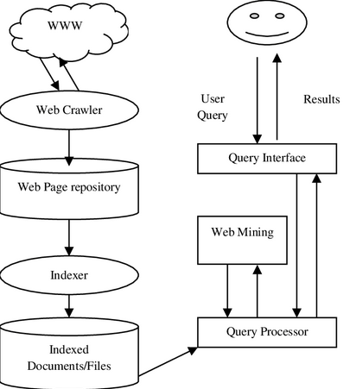

A web search engine is a software system designed to discover, store, index, and retrieve web pages in response to user queries. Its main components are as follows:

1️⃣ Web Crawler (Spider / Bot)
The web crawler is responsible for discovering and downloading web pages from the Internet.
It starts with a set of seed URLs, visits those pages, extracts hyperlinks, and recursively visits new pages. The downloaded pages are forwarded to the document repository.
Role:
- Collects web pages automatically
- Keeps content updated
- Forms the foundation of the search engine

2️⃣ Document Repository
The document repository stores the raw web pages fetched by the crawler.
It acts as a temporary or permanent storage before indexing.
Role:
- Stores HTML pages, metadata, and URLs
- Helps in re-indexing and caching

3️⃣ Indexer
The indexer processes the stored web pages to extract important terms, keywords, and metadata.
It removes stop words, performs stemming, and creates an inverted index.
Role:
- Converts unstructured web data into structured form
- Prepares data for fast searching

4️⃣ Index Database
The index database stores the inverted index, which maps keywords to the documents containing them.
Role:
- Enables fast query processing
- Stores term frequency, document IDs, and positions

5️⃣ Query Processor
The query processor accepts the user’s query, analyzes it, and matches it with the index database.
Role:
- Parses and refines the query
- Retrieves candidate documents
- Coordinates with ranking module

6️⃣ Ranking Module
The ranking module orders the retrieved pages based on relevance and importance.
Ranking is done using algorithms such as PageRank, HITS, link analysis, and content relevance.
Role:
- Assigns rank to each page
- Ensures most relevant pages appear first

7️⃣ User Interface (UI)
The user interface is the front-end through which users interact with the search engine.
Role:
- Accepts search queries
- Displays ranked results
- Provides filters and navigation

Indexing Systems:
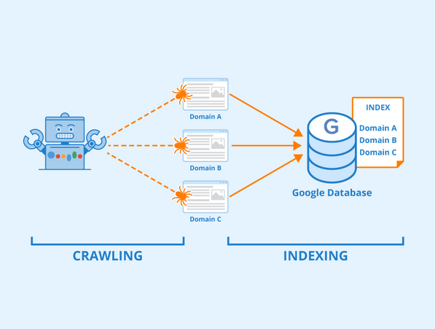
The indexing system is responsible for organizing and storing web content in a form that allows fast retrieval.
After pages are fetched by the crawler, the indexer extracts keywords, removes stop words, applies stemming, and builds an inverted index that maps terms to documents.
Purpose:
- Converts unstructured web pages into structured data
- Enables fast search and retrieval
- Reduces query processing time

Query processing and ranking:

Query processing involves analyzing the user’s search query and matching it with indexed documents.
The ranking process then orders the matched documents based on relevance scores.
Steps:
- Query parsing and normalization
- Matching query terms with index
- Scoring documents
- Ranking results
Goal:
To present the most relevant results at the top.

Scalability of web search engine:
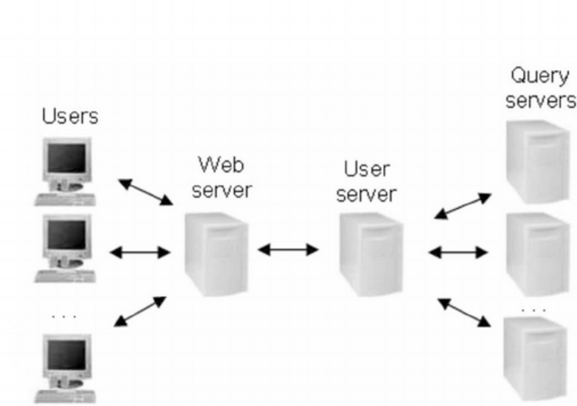

Scalability refers to the ability of a search engine to handle massive growth in:
- Number of web pages
- User queries
- Data storage
Modern search engines use distributed systems, parallel crawling, and distributed indexing to achieve scalability.
Importance:
- Supports billions of web pages
- Handles millions of queries per second
- Ensures fast response time
Scalability of a web search engine refers to its ability to handle rapid growth in web data, users, and queries without significant loss in performance, accuracy, or response time.

Why Scalability is Required
The World Wide Web is huge and continuously growing. A search engine must:
- Index billions of web pages
- Handle millions of queries per second
- Update data frequently
- Provide fast and accurate results
Scalability is a critical requirement of modern web search engines. By using distributed systems, parallel processing, and efficient indexing techniques, search engines can manage the ever-growing size and usage of the web effectively.

Scalability Challenges
- Large Volume of Web Pages – Continuous growth of online content
- High Query Load – Many users searching simultaneously
- Storage Requirements – Massive storage for indexed data
- Update Frequency – Pages change frequently
- Response Time – Users expect results in milliseconds

Techniques Used to Achieve Scalability

1️. Distributed Architecture
Search engines use multiple servers (clusters) instead of a single machine to store and process data.

2️. Parallel Crawling
Multiple crawlers work simultaneously to fetch web pages faster.

3️. Distributed Indexing
Indexes are divided across different machines to allow parallel searching.

4️. Load Balancing
User queries are distributed across servers to prevent overload on a single server.

5️. Caching
Frequently accessed queries and pages are stored in cache to reduce processing time.

6️. Incremental Indexing
Only updated or new pages are re-indexed instead of re-indexing the entire web.

Ranking through link analysis
Ranking through link analysis is a technique used by web search engines to rank web pages based on the link structure of the Web.
The basic idea is that a web page is considered important if it is linked by other important pages.

Basic Concepts
- In-links: Links pointing to a page
- Out-links: Links going from a page to other pages
- More quality in-links → higher rank

Why Link Analysis is Needed
- Keyword matching alone is not sufficient
- Helps identify authoritative and trustworthy pages
- Improves relevance of search results
- Reduces effect of spam pages
Algorithms:
- PageRank Algorithm
- Hyperlink-induced topic search (HITS)

Ranking through link analysis plays a crucial role in web search engines by evaluating the importance and relevance of web pages based on hyperlinks, leading to more accurate and reliable search results.

What is Web Mining?
Web Mining is the application of data mining techniques to discover useful patterns and knowledge from web data.
Web data includes:
- Web pages
- Hyperlinks
- User logs
- Clickstream data

Types of Web Mining

1️⃣ Web Content Mining
Deals with extracting information from web page contents.
Data types:
- Text
- Images
- Audio / Video
- Structured & unstructured data
Techniques used:
- Information extraction
- Text mining
- Natural language processing
Applications:
- News analysis
- Product review analysis
- Search result summarization

2️⃣ Web Structure Mining
Analyzes the link structure of the web.
Focus:
- In-links and out-links
- Relationship between pages
Used for:
- Page ranking
- Authority detection
👉 Algorithms: PageRank, HITS
(You already covered this — very good 👍)

3️⃣ Web Usage Mining
Extracts patterns from user interaction data.
Data sources:
- Server logs
- Browser logs
- Cookies
Steps:
- Data collection
- Data preprocessing
- Pattern discovery
- Pattern analysis
Applications:
- Personalization
- Recommendation systems
- Website optimization

Web Mining Process (Very Important ⭐)
- Resource discovery
- Data preprocessing
- Pattern discovery
- Pattern analysis

Difference Between the Three Types
Web Content | Web Structure | Web Usage
Page data | Link data | User behavior
Text/media | Hyperlinks | Logs, clicks
What is on page | How pages connect | How users use site

Applications of Web Mining
- Search engines
- Recommendation systems
- Business intelligence
- Fraud detection
- Web personalization

Multimedia search:
Web search engines cannot directly understand multimedia like humans do.
So they follow systematic processes to index and retrieve images, audio, and videos.
The World Wide Web contains a huge amount of multimedia data such as images, audio files, and videos.
Unlike text documents, multimedia data is unstructured and cannot be directly understood by computers. Therefore, web search engines use specialized techniques to index, analyze, and retrieve multimedia content.
Multimedia search is the process of retrieving relevant images, audio, and video from the web based on:
- User queries
- Content similarity
- Metadata
- User behavior
This process is a core part of Web Intelligence.

2. Overall Architecture of Multimedia Web Search
A multimedia search system generally consists of the following stages:
- Multimedia crawling
- Preprocessing and feature extraction
- Indexing and storage
- Query processing
- Similarity matching
- Ranking and result presentation
Each stage is applied differently for images, audio, and videos, which are explained in detail below.
Alright 👍
Now I’ll explain “How Image, Audio and Video Search is done on the Web” as a FULLY ELABORATED ~50 MARKS ANSWER, exactly in university-exam style.
You can literally write this with headings + diagram and score very high.

How Image, Audio and Video Search is Done on the Web
(Multimedia Search in Web Intelligence)
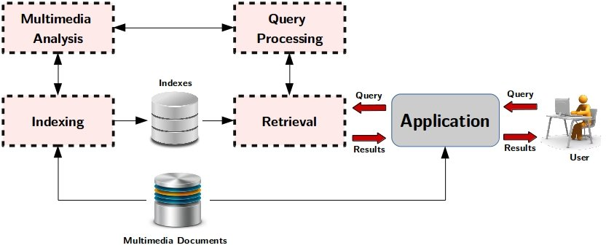

1. Introduction to Multimedia Search on the Web
The World Wide Web contains a huge amount of multimedia data such as images, audio files, and videos.
Unlike text documents, multimedia data is unstructured and cannot be directly understood by computers. Therefore, web search engines use specialized techniques to index, analyze, and retrieve multimedia content.
Multimedia search is the process of retrieving relevant images, audio, and video from the web based on:
- User queries
- Content similarity
- Metadata
- User behavior
This process is a core part of Web Intelligence.

2. Overall Architecture of Multimedia Web Search
A multimedia search system generally consists of the following stages:
- Multimedia crawling
- Preprocessing and feature extraction
- Indexing and storage
- Query processing
- Similarity matching
- Ranking and result presentation
Each stage is applied differently for images, audio, and videos, which are explained in detail below.

3. Image Search on the Web (Detailed)

3.1 Image Crawling
Search engines use web crawlers to locate and download images from web pages.
Along with the image file, crawlers also collect:
- Image URL
- File name
- ALT text
- Captions
- Surrounding textual content
This additional information helps in understanding the context of the image.

3.2 Image Preprocessing
Downloaded images may have different:
- Sizes
- Formats
- Resolutions
So preprocessing is performed to:
- Normalize image size
- Remove noise
- Convert formats
This ensures consistency in further processing.

3.3 Feature Extraction in Image Search
Since computers cannot understand images semantically, visual features are extracted.

(a) Color Features
- Color histograms
- Dominant colors

(b) Texture Features
- Surface patterns
- Repeated visual elements

(c) Shape Features
- Object boundaries
- Contours
These features together form a feature vector that numerically represents an image.

3.4 Image Indexing
Extracted features and metadata are stored in an image index database.
Indexing enables:
- Fast retrieval
- Efficient similarity comparison
Both text-based indexing and content-based indexing are used.

3.5 Image Query Processing
Users can search images in two ways:
- Text-based query (keywords like “sunset beach”)
- Query by example (uploading an image)
The system converts the query into feature form.

3.6 Similarity Matching and Ranking
Similarity between query image and stored images is calculated using distance measures.
Images are ranked based on:
- Feature similarity
- Metadata relevance
- Popularity

3.7 Applications of Image Search
- Google Images
- Medical diagnosis
- Satellite imagery
- E-commerce product search

4. Audio Search on the Web (Detailed)

4.1 Audio Crawling and Collection
Audio files are collected from:
- Music platforms
- Podcasts
- Online lectures
- Streaming services
Metadata such as artist, title, and genre is also collected.

4.2 Audio Preprocessing
Audio files may contain noise or silence.
Preprocessing includes:
- Noise reduction
- Signal normalization
- Segmentation

4.3 Audio Feature Extraction
Important features are extracted to represent audio signals numerically.
Key features include:
- Pitch
- Frequency
- Spectral features
- MFCC (Mel Frequency Cepstral Coefficients)
These features capture the unique characteristics of sound.

4.4 Audio Indexing
Extracted features and metadata are stored in an audio index.
This index supports:
- Fast search
- Pattern matching

4.5 Audio Query Methods
Users can search audio using:
- Text queries (song name, artist)
- Voice input
- Humming or melody matching

4.6 Matching and Ranking
The system compares query audio features with indexed features and ranks results based on:
- Similarity score
- Popularity
- User preferences

4.7 Applications of Audio Search
- Music identification (e.g., Shazam-like systems)
- Speech retrieval
- Podcast search
- Voice assistants

5. Video Search on the Web (Detailed)

5.1 Video Crawling
Search engines collect videos along with:
- Thumbnails
- Titles
- Descriptions
- Tags
- Comments

5.2 Video Segmentation
Videos are very large, so they are divided into:
- Frames
- Key frames
- Scenes
This reduces processing complexity.

5.3 Feature Extraction in Video Search
Video feature extraction is multi-dimensional:

(a) Visual Features
- Color
- Texture
- Object detection

(b) Motion Features
- Movement patterns
- Object tracking

(c) Audio Features
- Background sound
- Speech

(d) Text Features
- Speech-to-text conversion
- Subtitles

5.4 Video Indexing
All extracted features are stored in a video index database, enabling:
- Scene-level search
- Content-based retrieval

5.5 Video Query Processing
Users can search videos using:
- Keywords
- Images
- Video clips

5.6 Ranking of Video Results
Ranking is done using:
- Content relevance
- User engagement
- Popularity
- Watch time

5.7 Applications of Video Search
- YouTube search
- Surveillance systems
- Educational platforms
- Media archives

6. Challenges in Multimedia Web Search
- Huge data volume
- High storage requirements
- High computational cost
- Semantic gap between machine and human understanding
- Real-time response requirements

7. Advantages of Multimedia Web Search
- Enables rich content retrieval
- Improves user experience
- Supports modern applications
- Enhances web intelligence

8. Conclusion
Multimedia search on the web is a complex yet essential component of Web Intelligence systems.
By combining crawling, feature extraction, indexing, similarity matching, and ranking techniques, search engines efficiently retrieve images, audio, and videos, making vast multimedia content accessible to users.

1. Image Mining

1.1 Introduction to Image Mining
Image mining is the process of discovering meaningful patterns, relationships, and knowledge from large collections of images.
Unlike image processing (which focuses on enhancement), image mining focuses on knowledge extraction.
In Web Intelligence, image mining is used to analyze images available on the web such as:
- Medical images
- Satellite images
- Social media images
- E-commerce product images

Short Text Mining
Short text mining refers to the extraction of useful information from very short text data such as:
- Tweets
- SMS
- Search queries
- Chat messages
- Product reviews
Short texts usually contain limited context, making mining difficult.

2.2 Characteristics of Short Text
- Very few words
- Informal language
- Abbreviations and slang
- High ambiguity

Text Pre-processing in Text Mining
Text pre-processing is a crucial step in text mining and web intelligence.
Raw text data collected from the web (tweets, reviews, short messages, web pages) is usually noisy, inconsistent, and unstructured.
Text pre-processing converts this raw text into a clean, consistent, and structured form, suitable for mining and analysis.
The main steps involved in text pre-processing are:
- Data Cleaning
- Data Integration
- Data Transformation
- Segmentation

1. Data Cleaning

Definition
Data cleaning is the process of removing irrelevant, incorrect, duplicate, or noisy data from raw text.
Web text often contains:
- Spelling mistakes
- Special symbols
- Emojis
- HTML tags
- Stop words
These reduce the accuracy of mining results.

Operations in Data Cleaning

(a) Removal of Noise
Noise includes:
- HTML tags
- URLs
- Special characters (@, #, %, etc.)
- Emojis
Example:
<html>Great product!!! 😊</html>
After cleaning → Great product

(b) Stop-word Removal
Stop words are commonly used words that carry little semantic meaning.
Examples:
- is, am, the, a, an, of, to
Removing them reduces data size and improves efficiency.

(c) Spelling Correction
Misspelled words are corrected to maintain consistency.
Example:
- “amazng” → “amazing”

(d) Duplicate Removal
Repeated text entries are removed to avoid bias in analysis.

Importance of Data Cleaning
- Improves data quality
- Reduces processing time
- Increases accuracy of mining results

2. Data Integration

Definition
Data integration is the process of combining text data from multiple sources into a single unified dataset.
In web intelligence, data may come from:
- Social media platforms
- Web pages
- Online forums
- Review websites

Need for Data Integration
Different data sources may:
- Use different formats
- Contain redundant or inconsistent data
Integration ensures uniform representation.

Steps in Data Integration

(a) Source Identification
Identify all text data sources.

(b) Data Matching
Identify and merge related text from different sources.

(c) Conflict Resolution
Resolve inconsistencies such as:
- Different spellings
- Different naming conventions

Example
A product review may appear on:
- Amazon
- Flipkart
Integration merges both reviews into one dataset.

Advantages of Data Integration
- Provides complete information
- Improves knowledge discovery
- Reduces redundancy

3. Data Transformation

Definition
Data transformation converts cleaned and integrated text into a suitable format for mining algorithms.
Most algorithms require numerical input, so text must be transformed.

Methods of Data Transformation

(a) Tokenization
Breaking text into individual words or tokens.
Example:
“Web intelligence is powerful” →
[Web, intelligence, is, powerful]

(b) Case Normalization
Converting text into a single case (usually lowercase).
Example:
“DATA Mining” → “data mining”

(c) Stemming
Reducing words to their root form.
Example:
- running → run
- connected → connect

(d) Lemmatization
Converting words to meaningful base forms.
Example:
- better → good

(e) Vector Representation
Text is represented numerically using:
- Bag of Words (BoW)
- TF-IDF

Importance of Data Transformation
- Makes text machine-understandable
- Reduces dimensionality
- Improves mining performance

4. Segmentation

Definition
Segmentation is the process of dividing text into smaller meaningful units for analysis.

Types of Segmentation

(a) Sentence Segmentation
Dividing text into sentences.
Example:
“This is web mining. It is useful.” →
Two sentences

(b) Word Segmentation
Dividing sentences into words or terms.

(c) Document Segmentation
Splitting large documents into smaller sections.

Role of Segmentation
- Improves context understanding
- Helps in topic modeling
- Enhances classification accuracy

Example
A long article is segmented into:
- Introduction
- Body
- Conclusion
Each segment is analyzed separately.

Overall Importance of Text Pre-processing
Text pre-processing:
- Reduces noise and ambiguity
- Improves accuracy of text mining
- Enhances efficiency of web intelligence systems
Without proper pre-processing, mining results may be incorrect or misleading.

Conclusion
Text pre-processing is a foundational step in text mining and web intelligence.
By performing data cleaning, data integration, data transformation, and segmentation, raw web text is converted into structured and meaningful data, enabling accurate and effective knowledge discovery.

Image Pre-processing
(Histogram Analysis, Noise Cleaning and Segmentation)
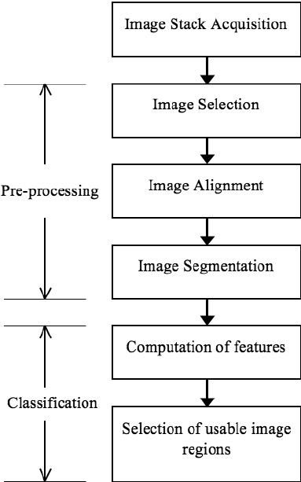

1. Introduction to Image Pre-processing
Image pre-processing is an important initial step in image mining and multimedia analysis.
Raw images collected from the web or databases often suffer from:
- Noise
- Poor contrast
- Irrelevant background
- Inconsistent resolution
Pre-processing improves image quality and prepares images for feature extraction and mining.
The main steps involved in image pre-processing are:
- Image Histogram Analysis
- Noise Cleaning
- Image Segmentation

2. Image Histogram Analysis

Definition
An image histogram is a graphical representation of the distribution of pixel intensity values in an image.
It shows:
- X-axis → Intensity values (0–255 for grayscale images)
- Y-axis → Number of pixels
Histogram analysis helps in understanding the brightness, contrast, and overall quality of an image.

Purpose of Histogram Analysis
- Analyze image contrast
- Detect underexposed or overexposed images
- Enhance image quality
- Prepare image for further processing

Types of Image Histograms

(a) Grayscale Histogram
Represents distribution of grayscale intensity values.

(b) Color Histogram
Represents distribution of color components (RGB).

Histogram Equalization
Histogram equalization is used to improve contrast by redistributing intensity values uniformly.
Example:
A dark image can be enhanced by spreading pixel values across the full intensity range.

Importance in Image Mining
- Improves visibility of objects
- Enhances feature extraction
- Makes images comparable

3. Noise Cleaning (Noise Removal)

Definition
Noise cleaning is the process of removing unwanted distortions present in an image that degrade its quality.
Noise may be introduced due to:
- Poor sensors
- Transmission errors
- Environmental conditions

Types of Noise in Images
- Salt and pepper noise
- Gaussian noise
- Speckle noise

Noise Cleaning Techniques

(a) Mean Filter
Replaces each pixel value with the average of neighboring pixels.

(b) Median Filter
Replaces pixel value with the median of neighboring values.
Very effective for salt and pepper noise.

(c) Gaussian Filter
Uses a weighted average to smooth the image.

Role of Noise Cleaning
- Improves image clarity
- Reduces false patterns
- Increases accuracy of segmentation and feature extraction

Example
A noisy medical image is cleaned before detecting tumors to avoid incorrect diagnosis.

4. Image Segmentation

Definition
Image segmentation is the process of dividing an image into meaningful regions or objects.
Each segment represents a region with similar properties such as:
- Color
- Texture
- Intensity

Purpose of Image Segmentation
- Identify objects of interest
- Separate foreground from background
- Simplify image representation

Types of Image Segmentation Techniques

(a) Threshold-Based Segmentation
Divides image based on intensity threshold values.
Example:
Pixels above threshold → object
Pixels below threshold → background

(b) Edge-Based Segmentation
Detects boundaries using edges.
Uses operators like:
- Sobel
- Canny

(c) Region-Based Segmentation
Groups neighboring pixels with similar properties.

(d) Clustering-Based Segmentation
Uses algorithms like K-means to group pixels.

Importance in Image Mining
- Enables object detection
- Improves classification accuracy
- Reduces computational complexity

5. Role of Image Pre-processing in Image Mining
Image pre-processing:
- Enhances image quality
- Removes irrelevant data
- Improves feature extraction
- Increases mining accuracy
Without pre-processing, extracted patterns may be incorrect or misleading.

6. Applications
- Medical imaging
- Satellite image analysis
- Face recognition
- Surveillance systems
- Image search engines

7. Conclusion
Image pre-processing is a fundamental step in image mining and multimedia search systems.
By performing image histogram analysis, noise cleaning, and segmentation, raw images are transformed into high-quality, meaningful data suitable for accurate feature extraction and knowledge discovery.

Classification Algorithms:
- Linear regression:
In simple terms, linear regression in WEB Intelligence is like drawing the "line of best fit" on a chart to predict future trends from past data, finding a straight-line relationship between things like ad spend (input) and website visits (output) to help businesses make smarter decisions, like forecasting sales or understanding customer behaviour. It helps turn raw data into understandable business insights by finding patterns, such as "for every $1 spent on ads, we get 5 visitors".
What it is:
- Finding a straight-line connection: It looks for a linear relationship (a straight line) between an input (independent variable, e.g., ad spend) and an output (dependent variable, e.g., sales).
- Predicting the future: It uses this line to predict what the output might be for a new input, based on historical data.

- Decision Tree :
decision tree is a fundamental, interpretable machine learning algorithm used in web intelligence to make predictions or classify data by recursively splitting datasets into smaller, more homogeneous subsets. It operates like a flowchart, providing a clear, visual path from a root node through internal decision nodes and branches to a final leaf node (outcome).
In the context of web intelligence, decision trees help analyse large volumes of online data to support automated and informed decision-making.
Key Components
Decision trees are composed of three main types of nodes:
- Root Node: The starting point representing the entire dataset and the initial decision or question.
- Internal (Decision) Nodes: Points within the tree that test a specific attribute or feature (e.g., "Customer spent over $50?").
- Branches: The outcome of a decision or chance event, leading to the next node.
- Leaf (End) Nodes: The final nodes of the tree that represent the ultimate prediction or class label (e.g., "Purchase" or "No Purchase").
How They Are Used in Web Intelligence
Decision trees are a versatile tool in web intelligence due to their ability to handle various data types and their high interpretability.
- Customer Churn Prediction: A company can use a decision tree to identify which website users are likely to cancel their service based on factors like login frequency, contract type, and support interactions.
- Loan Approval/Fraud Detection: Financial institutions leverage decision trees to assess credit risk or detect fraudulent transactions by analyzing historical financial data and user behavior patterns.
- Targeted Marketing: Marketers can segment online audiences and predict customer behavior to tailor ad campaigns based on browsing history, demographics, and past purchases.
- Medical Diagnosis Support: In health-related web applications, decision trees can help prioritize patient care or suggest potential diagnoses based on user-reported symptoms and health data.
Algorithms and Implementation
Building an effective decision tree in web intelligence involves specific algorithms and techniques to ensure accuracy and prevent overfitting.
- Algorithms: Common algorithms include ID3, C4.5, and CART (Classification and Regression Trees), which is the basis for many modern implementations like scikit-learn in Python.
- Splitting Criteria: Algorithms use metrics like Information Gain (maximizing the reduction in uncertainty) or Gini Impurity (measuring how often a randomly chosen element would be misclassified) to determine the best feature to split at each node.
- Pruning: To prevent the model from becoming too complex and overfitting the training data, techniques like pruning (removing unnecessary branches) are used to improve generalization to new, unseen data.
- K-Means in Web Intelligence (Classification Support)
K-Means is an unsupervised clustering algorithm, but in Web Intelligence it is often used as a pre-classification step. The K-means algorithm is an unsupervised machine learning technique used to automatically find and group similar items (data points) into a specific number of groups, called clusters, without needing predefined labels. In "web intelligence," this is used to uncover hidden patterns in online behaviour and data.
Simple Explanation of the Concept
Imagine you have a large pile of unlabelled customer data from a website (like purchase history, browsing time, etc.) and you want to organize them into a few distinct groups for marketing purposes (e.g., "high-value shoppers," "occasional browsers," etc.). Since you don't know the groups in advance, you use K-means to discover these natural groupings automatically.
The algorithm works like this: it finds the "centre" (called a centroid) for each group and makes sure every customer belongs to the cluster with the closest center. It does this iteratively until the groups are well-defined and stable.

Role in Web Intelligence
- Group similar web pages
- Cluster users based on browsing behavior
- Segment documents before labeling

Example
- Group news articles into topics
- Later assign cluster labels like sports, politics, technology

Importance
- Reduces complexity of large web datasets
- Improves efficiency of classification systems
How the Algorithm Works Step-by-Step
The process, known as Lloyd's algorithm, is an iterative refinement technique:
- Choose the Number of Clusters (K): You decide how many groups you want to find (e.g., 𝐾=3 customer types).
- Initialize Centroids: The algorithm randomly places K initial "center points" (centroids) within your data.
- Assign Data Points: Each data point (e.g., a customer's data) is assigned to the nearest centroid, usually based on Euclidean distance.
- Update Centroids: The position of each centroid is recalculated to be the true average (mean) location of all the data points assigned to its cluster.
- Repeat: Steps 3 and 4 are repeated until the centroids stop moving significantly or the cluster assignments no longer change, meaning the algorithm has converged on a stable solution.
Use in Web Intelligence
In web intelligence and business analytics, K-means is widely used for:
- Customer Segmentation: Grouping website visitors based on browsing behavior or purchase history to deliver personalized content or targeted ads.
- Recommendation Systems: Identifying users with similar preferences to recommend products or content (e.g., "users who liked this also liked...").
- Anomaly/Fraud Detection: Flagging unusual data points (outliers) that fall far from any cluster, which could indicate fraudulent transactions or security threats.
- Document Clustering: Organizing large volumes of web pages, articles, or support tickets into topical groups for easier search and information management.
- Image Compression: Grouping similar pixel colors in an image to reduce file size for faster web loading times.
- Naïve Bayes:

Naive Bayes is a simple but powerful probabilistic classification algorithm used in web intelligence to make predictions or categorize content by calculating the likelihood of different outcomes based on available information.
How it Works (in Simple Language)
Imagine a spam filter in your email (a classic web intelligence application). Naive Bayes works by looking at the words in an email to decide if it's "spam" or "not spam" (the classes).
• Learning from Experience (Training): The system "learns" from thousands of past emails that are already labeled as "spam" or "not spam." It counts how often certain words appear in each type of email. For example, the word "free" might appear in 70% of spam emails but only 1% of legitimate ones.
• The "Naive" Assumption: The algorithm is called "naive" because it makes a very simple assumption: it assumes that the presence of one word (e.g., "free") has no effect on the presence of another word (e.g., "money") in the same email, given the class. In reality, these words often appear together, but the algorithm ignores that dependency to make calculations faster and simpler.
• Making a Decision (Prediction): When a new email arrives, Naive Bayes uses the counts it learned to calculate two main probabilities using Bayes' theorem:
- The probability that the email is "spam".
- The probability that the email is "not spam".
• The Winner Takes All: The email is then classified into the category with the highest probability.

Naive Bayes is a machine learning classification algorithm that predicts the category of a data point using probability. It assumes that all features are independent of each other. Naive Bayes performs well in many real-world applications such as spam filtering, document categorization and sentiment analysis.

What is Big Data?
Big Data refers to extremely large, complex, and rapidly growing datasets that cannot be efficiently stored, processed, or analyzed using traditional data processing tools. These datasets require advanced technologies and techniques to extract meaningful insights.
Big Data is a collection of data that is high in volume, velocity, and variety, and which requires specialized tools and frameworks for storage, processing, and analysis.

Characteristics of Big Data (The 5 V’s)

1️⃣ Volume
- Refers to the huge amount of data generated every second
- Example: social media posts, sensor data, transaction logs

2️⃣ Velocity
- Speed at which data is generated and processed
- Example: real-time data from IoT devices, live streams

3️⃣ Variety
- Different forms of data:
  - Structured (databases, tables)
  - Semi-structured (JSON, XML)
  - Unstructured (text, images, videos)

4️⃣ Veracity
- Quality and reliability of data
- Deals with noise, uncertainty, and inconsistency

5️⃣ Value
- Extracting useful insights and business intelligence from data

Sources of Big Data
- Social media platforms
- Web logs and clickstream data
- IoT devices and sensors
- Multimedia data (images, videos)
- Online transactions

Big Data Technologies
- Hadoop (HDFS, MapReduce)
- Spark
- NoSQL databases (MongoDB, Cassandra)
- Cloud platforms

Big Data is required to store, process, and analyze massive, fast, and diverse datasets efficiently. It enables organizations and intelligent systems to extract meaningful insights, support real-time decisions, and handle the ever-growing scale of modern data.

Applications of Big Data in Web Intelligence

1. Search Engines and Information Retrieval
Big Data plays a crucial role in modern search engines such as Google and Bing.
- Processes billions of web pages
- Handles millions of user queries per second
- Improves ranking using user behavior data
Example:
Analyzing click-through rates and query logs to improve search relevance.

2. Web Mining and Knowledge Discovery
Big Data enables large-scale:
- Web content mining
- Web structure mining
- Web usage mining
These techniques help extract hidden patterns and useful knowledge from massive web datasets.
Example:
Discovering trending topics from social media posts.

3. Personalization and Recommendation Systems
By analyzing large user datasets, Big Data helps provide:
- Personalized search results
- Product recommendations
- Content suggestions
Example:
Netflix and Amazon recommend content based on user browsing and viewing history.

4. Social Media Analytics
Social media platforms generate huge volumes of data every second.
Big Data is used to:
- Analyze user opinions
- Detect trends
- Perform sentiment analysis
Example:
Analyzing tweets to understand public opinion on events.

5. Sentiment and Opinion Mining
Big Data techniques analyze:
- Reviews
- Comments
- Feedback
This helps organizations understand customer satisfaction and market trends.
Example:
Classifying product reviews as positive or negative.

6. Online Advertising and Marketing
Big Data helps in:
- Targeted advertising
- User behavior analysis
- Ad performance optimization
Example:
Displaying ads based on user search history and interests.

7. Fraud Detection and Security
Web Intelligence systems use Big Data to:
- Detect unusual user behavior
- Identify fraudulent transactions
- Prevent cyber attacks
Example:
Detecting fake accounts and click fraud.

8. Web Traffic and Usage Analytics
Big Data helps analyze:
- Website traffic
- User navigation paths
- Clickstream data
This improves:
- Website design
- User experience
- System performance

9. Real-Time Web Analytics
Big Data enables real-time processing of web data such as:
- Live clicks
- Streaming content
- User interactions
This supports quick decision making.

10. Multimedia Data Analysis
Big Data supports analysis of:
- Images
- Audio
- Videos
Used in:
- Image search
- Video recommendation
- Surveillance systems

11. Smart Services and Decision Support
Big Data helps Web Intelligence systems:
- Predict user behavior
- Support business decisions
- Optimize services

Conclusion
Big Data is a fundamental component of Web Intelligence as it enables the storage, processing, and analysis of massive and diverse web data. Its applications range from search engines and personalization to security and social media analytics, making web systems more intelligent, scalable, and efficient.

Big Data Analytics
Big Data Analytics refers to the process of examining, processing, and analyzing large, complex datasets (Big Data) to discover hidden patterns, correlations, trends, and useful insights that support intelligent decision making.
Traditional data analysis tools are insufficient for Big Data because of its volume, velocity, and variety. Therefore, advanced analytics techniques and distributed computing frameworks are used.

2. Definition (Exam-ready)
Big Data Analytics is the systematic process of analyzing massive, fast-moving, and diverse datasets using advanced analytical techniques to extract meaningful information and support decision making.

3. Need for Big Data Analytics
Big Data Analytics is required because:
- Data is generated in huge volumes
- Data arrives at high speed
- Data exists in multiple formats (text, image, video, logs)
- Organizations need real-time insights
Without analytics, Big Data has no value.

4. Big Data Analytics Process

1️⃣ Data Collection
Data is collected from:
- Web logs
- Social media
- IoT sensors
- Transactions
- Multimedia sources

2️⃣ Data Storage
Due to large size, data is stored using:
- HDFS (Hadoop Distributed File System)
- NoSQL databases
- Cloud storage

3️⃣ Data Preprocessing
Includes:
- Data cleaning
- Data integration
- Data transformation
This improves data quality before analysis.

4️⃣ Data Analysis
Analytics techniques are applied such as:
- Data mining
- Machine learning
- Statistical analysis
- Text and image analytics

5️⃣ Visualization & Interpretation
Results are presented using:
- Charts
- Dashboards
- Reports
This helps users understand insights easily.

5. Types of Big Data Analytics

5.1 Descriptive Analytics
- Describes what happened
- Uses historical data
Example: Website traffic analysis

5.2 Diagnostic Analytics
- Explains why it happened
- Finds root causes
Example: Why sales dropped last month

5.3 Predictive Analytics
- Predicts what will happen
- Uses machine learning
Example: Predicting customer behavior

5.4 Prescriptive Analytics
- Suggests what should be done
- Supports decision making
Example: Recommendation systems

6. Tools and Technologies Used
- Hadoop (HDFS, MapReduce)
- Apache Spark
- NoSQL databases
- Cloud platforms

7. Role of Big Data Analytics in Web Intelligence
In Web Intelligence, Big Data Analytics is used to:
- Improve search engine ranking
- Analyze user behavior
- Perform sentiment analysis
- Enable personalization
- Detect fraud and spam

8. Applications of Big Data Analytics
- Search engines
- Recommendation systems
- Social media analytics
- Healthcare analytics
- Fraud detection
- Smart cities

9. Advantages of Big Data Analytics
- Better decision making
- Real-time insights
- Improved customer experience
- Scalability and flexibility

11. Conclusion
Big Data Analytics transforms massive and complex datasets into valuable knowledge. It plays a vital role in Web Intelligence by enabling intelligent search, personalization, prediction, and decision support. Without analytics, Big Data cannot deliver its true potential.

Challenges in Big Data (Simple & Easy)

1. Huge Amount of Data (Volume)
Big Data involves very large datasets.
Storing and managing such a huge amount of data needs special systems and large storage.
Example: Social media generates millions of posts every minute.

2. Fast Data Generation (Velocity)
Data is produced very quickly and sometimes in real time.
It is difficult to process and analyze data at such high speed.
Example: Live user clicks on websites.

3. Different Types of Data (Variety)
Big Data comes in many forms:
- Text
- Images
- Videos
- Audio
Handling all these data types together is challenging.

4. Data Quality Problems (Veracity)
Big Data often contains:
- Errors
- Noise
- Duplicate data
- Incomplete information
Poor quality data leads to wrong results.

5. Storage and Management
Traditional databases cannot store Big Data efficiently.
Big Data requires distributed storage systems, which are complex to manage.

6. Data Processing Complexity
Analyzing Big Data needs:
- High computing power
- Special tools like Hadoop and Spark
This makes processing complex and costly.

7. Security and Privacy Issues
Big Data contains sensitive personal information.
Protecting data from misuse, hacking, and unauthorized access is difficult.

8. Lack of Skilled Professionals
Big Data systems require trained experts.
There is a shortage of skilled Big Data professionals.

9. Cost
Setting up Big Data infrastructure is expensive, including:
- Hardware
- Software
- Maintenance

10. Data Integration
Data comes from many sources.
Combining all data into a single format is difficult.

Conclusion (Easy)
Big Data provides many benefits, but it also faces challenges related to size, speed, variety, quality, security, and cost. Overcoming these challenges is necessary to use Big Data effectively.

NoSQL
NoSQL (Not Only SQL) is a type of database designed to handle large-scale, distributed, and unstructured or semi-structured data.
NoSQL (Not Only SQL) refers to a class of databases designed to handle Big Data, distributed systems, and unstructured or semi-structured data. Unlike relational databases, NoSQL databases do not rely on fixed schemas or table-based structures. Instead, they provide flexible data models, high scalability, and high availability, making them suitable for modern web applications and Web Intelligence systems.
👉 Used where Big Data and Web Intelligence are involved.

2. Why NoSQL?
Traditional relational databases:
- Don’t scale well
- Work mainly with structured data
NoSQL is used because it:
- Handles huge data volume
- Supports high speed
- Stores unstructured data
- Scales horizontally

3. Features of NoSQL (Very Important)
- Schema-less (no fixed table structure)
- High scalability
- High availability
- Distributed architecture
- Faster read/write
- Handles Big Data & real-time data

4. Types of NoSQL Databases ⭐

1️⃣ Key–Value Stores
- Data stored as key : value
- Very fast
Example: Redis, DynamoDB
Use: Caching, session management

2️⃣ Document-Oriented Databases ⭐
- Data stored as JSON / BSON documents
Example: MongoDB, CouchDB
Use: Web applications, content management

3️⃣ Column-Oriented Databases
- Data stored in columns instead of rows
Example: Cassandra, HBase
Use: Big Data analytics

4️⃣ Graph Databases
- Data stored as nodes and edges
Example: Neo4j
Use: Social networks, recommendation systems

Aggregate data model
The aggregate data model in NoSQL treats related data as a single, cohesive unit (an "aggregate"), like a customer order containing details, products, and payments, rather than splitting them across separate tables as in relational databases. This simplifies data management, improves performance by reducing the need for joins, and aligns data structure with application objects, making it ideal for scalable systems. Key NoSQL types using this model include Key-Value, Document, Column Family, and Graph databases.

Key Concepts
- Unit of Data: A collection of related data treated as a single, indivisible entity for storage and retrieval.
- Cohesion: Keeps related data together (e.g., an order with its items).
- Simplicity: Avoids complex joins, making data fetching faster.
- Scalability: Aggregates can be distributed across clusters easily.
- Consistency Boundaries: Defines the scope for ACID (Atomicity, Consistency, Isolation, Durability) operations, though often with weaker guarantees than relational systems.
Common NoSQL Aggregate Models
- Key-Value: Stores data as simple key-value pairs, excellent for session data.
- Document: Stores data in flexible, nested documents (like JSON), allowing complex structures within one record.
- Column Family: Stores data in rows with flexible columns, great for big-table style data.
- Graph: Models data as nodes and edges, perfect for complex relationships (social networks).
Why It's Used
- Performance: Faster reads and writes because data isn't scattered across many tables.
- Scalability: Easier to scale horizontally by distributing aggregates.
- Developer Productivity: Matches application objects, reducing the object-relational impedance mismatch.

HADOOP :
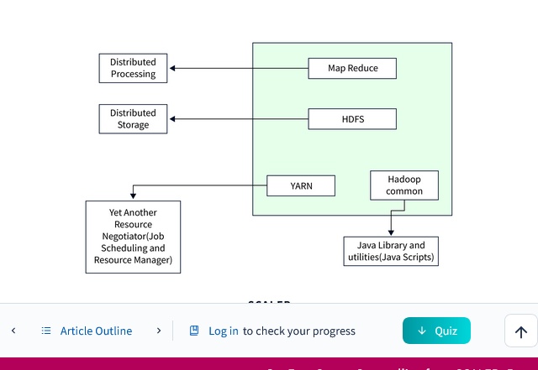

In a distributed computing environment, vast volumes of data can be stored and processed using the open-source Hadoop framework. Understanding the hadoop architecture become crucial as it offers a dependable, scalable, adaptable, and distributed computing Big Data platform.
Hadoop's architecture provides scalability, fault tolerance, and cost-effective storage and processing capabilities, making it a popular choice for Big Data applications and analytics. This article helps to understand key components of Hadoop's architecture.
Hadoop high-level architecture proves to seamlessly handle Big data issues and enables fault-tolerant and scalable storage, processing, and analysis.
The high-level architecture of Hadoop comprises of the following core components and their interactions to enable distributed storage and processing of large datasets.
- MapReduce: A programming model for parallel processing and analyzing large datasets across a Hadoop cluster
- HDFS(Hadoop Distributed File System): Stores data across a cluster of nodes, providing fault tolerance.
- YARN (Yet Another Resource Negotiator): Manages cluster resources and scheduling of data processing tasks.
- Hadoop Common (Utilities): Provides shared libraries and utilities essential for the functioning of the entire Hadoop ecosystem.

The Hadoop Architecture Modules

MapReduce
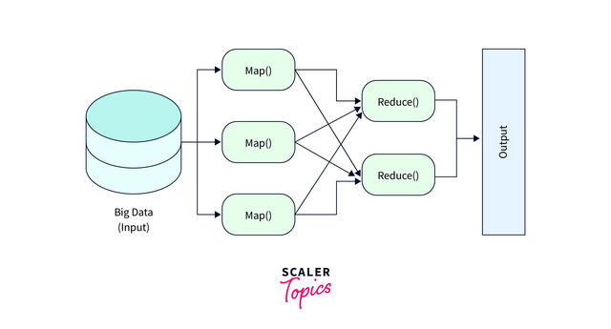
i. Map Task
- RecordReader RecordReader creates key-value pairs for the Mapper to process by reading and parsing data from input splits (small portions of the input data). Different input formats (e.g., TextInputFormat, SequenceFileInputFormat) in Hadoop have corresponding RecordReader implementations to handle the specific data formats.
- Map A map can be considered as a user define function that processes the key-value pairs retrieved from a record reader as well as applies a specified transformation to produce these key-value pairs.
- Combiner The Combiner decrease the amount of data transferred over the network and increases the MapReduce job's overall efficiency.
- Partitionar The key-value pairs produced in the Mapper Phases are fetched by the Partitioner. Each reducer's matching shard is created by the partitioner. This partition also retrieves each key's hashcode. Then partitioner performs the following formula (key.hashcode()%(number of reducers)) on each hashcode.
ii. Reduce Task
- Shuffle and Sort Hadoop Shuffle and Sort organizes and transfers data from Mapper outputs to appropriate Reducers based on keys, enabling effective data aggregation during the Reduce phase.
- Reduce Gathering the Tuple produced by Map and performing some sort of aggregation operation on those key-value pairs.
- OutputFormat Record writer is used to write the key-value pairs into the file, with each record starting on a new line and the key and value being separated by spaces.
  - HDFS (Hadoop Distributed File System)
i. NameNode(Master)
The NameNode (Master), is in charge of managing the file system namespace, keeping track of the metadata for files and directories, and mapping data blocks to DataNodes. The Secondary NameNode helps to improve fault tolerance because it represents a single point of failure.
ii. DataNode(Slave)
The actual data blocks that makeup files in HDFS are stored and served by DataNodes, which are "Slave" nodes in HDFS. They manage block replication, issue recurrent heartbeats to signal availability and communicate block status to the NameNode.
iii. Job Tracker
The HDFS job tracker manages and carries out MapReduce jobs.
iv. Task Tracker
The "TaskTracker" was in Hadoop 1.x as it was in charge of carrying out certain tasks within MapReduce jobs. However, in Hadoop2.x it was abandoned."
For more information, refer [HDFS (Hadoop Distributed File System]

YARN (Yet Another Resource Negotiator)
The resource management framework known as YARN, or "Yet Another Resource Negotiator," was first included in Hadoop 2.x where it worked by separating resource management from data processing.
YARN offers scalability, multi-tenancy, flexibility and effective resource allocation.

Hadoop Common (Utilities or Hadoop Common)
Essential shared libraries and utilities utilized by all Hadoop components are provided by Hadoop Common Utilities. File I/O, networking, configuration management, logging, security, compression, and other features are all included. The construction of distributed applications and data processing activities is made simpler by these tools, which guarantee the seamless integration and operation of Hadoop ecosystem components.

Practices of Big Data Analytics
Big Data Analytics practices refer to the systematic methods, activities, and steps followed to collect, process, analyze, manage, and use large volumes of data in order to extract useful insights, patterns, and knowledge for decision-making.
In simple words, these practices explain how big data is handled from raw data to final insight.

1. Data Collection
This practice focuses on gathering data from multiple sources.
Sources include:
- Social media
- Web logs
- Sensors and IoT devices
- Mobile applications
- Transactional systems
- Emails, images, audio, video
👉 Data can be structured, semi-structured, or unstructured.

2. Data Storage and Management
Collected data must be stored efficiently due to its large size and fast growth.
Practices include:
- Using distributed storage systems like HDFS
- NoSQL databases (HBase, MongoDB, Cassandra)
- Cloud storage solutions
- Data replication and fault tolerance
👉 Ensures scalability, reliability, and availability of data.

3. Data Cleaning and Preprocessing
Raw data is often incomplete, noisy, and inconsistent.
This practice involves:
- Removing duplicate data
- Handling missing values
- Noise removal
- Data normalization
- Data integration from multiple sources
👉 Clean data improves accuracy of analytics results.

4. Data Transformation
Data is transformed into a suitable format for analysis.
Includes:
- Aggregation
- Encoding categorical values
- Feature selection
- Feature extraction
- Data reduction
👉 Makes data ready for analysis models.

5. Data Processing
Processing big data requires parallel and distributed computing.
Practices include:
- Batch processing (Hadoop MapReduce)
- Stream processing (Spark Streaming, Kafka)
- In-memory processing (Apache Spark)
👉 Enables fast processing of huge datasets.

6. Data Analysis and Modeling
This is the core practice of big data analytics.
Techniques used:
- Descriptive analytics (what happened)
- Diagnostic analytics (why it happened)
- Predictive analytics (what will happen)
- Prescriptive analytics (what should be done)
Tools & methods:
- Machine learning
- Data mining
- Statistical analysis
- AI algorithms

7. Data Visualization
Analyzed data is presented in a visual and understandable form.
Includes:
- Charts
- Graphs
- Dashboards
- Reports
👉 Helps stakeholders understand insights quickly.

8. Decision Making and Action
Insights generated from analytics are used for:
- Business strategies
- Policy formulation
- Risk management
- Customer behavior analysis
👉 This practice converts data insights into real actions.

9. Data Security and Privacy
Big data often contains sensitive information.
Practices include:
- Data encryption
- Access control
- Authentication
- Compliance with data protection laws
👉 Ensures safe and ethical use of data.

10. Continuous Monitoring and Improvement
Big data analytics is an ongoing process.
Includes:
- Monitoring data quality
- Updating models
- Improving algorithms
- Handling new data streams
👉 Keeps analytics accurate and up-to-date.

Conclusion
The practices of big data analytics provide a structured approach to handling massive and complex datasets. By following these practices, organizations can transform raw data into valuable insights, leading to better decisions, improved performance, and competitive advantage.

